PHASE 1: for the following questions, users will rank

• Strongly Disagree
• Disagree
• Neutral (or Neither Agree nor Disagree)
• Agree
• Strongly Agree

And once users done with the whole questionnaire, wavelength will identify 2 items that it wants to interview the user about. The selection of the item is based on 1, how negative it was scored and (if within the same zone, pick ones that were scored negatively) 2, how far up the scale it appeared (e.g. we prioritize ‘safe to belong’ zone over ‘save to speak freely’ zone).
Below are all of the question items, along with examples of how Otis would probe deeper into their answers by eliciting a specific situation (context & objective), behaviors (primarily negative ‘out’ behaviors), results/outcomes, and ‘in’ behaviors they would have wanted to see instead.
1. Safe to Belong
- On this team, everyone treats one another with respect
  - If responses land on “Neutral, Disagree, Strongly Disagree”:
    - “I want to focus on some of your responses. Your responses ‘[enter their response e.g. ‘Disagree.’] To the question ‘On this team, everyone treats one another with respect’ “
    - “Can you give me an example that led you to give this answer? Think about a situation from the recent past that involved at least part of your team. It might have been a moment during a meeting, a project, or something else.
Please describe:
      - What was happening, and what was the objective?
      - What did people do or say that led you to your response?
      - What effect did that have on you, your work, or the team in general?
    - “Take a moment to think about a situation and then tell me: what was happening and what was the objective? “
      - (situation: Desired response should ideally include information that sets the scene, like the context, what was going on or what people were doing, like was it during a meeting, how many people were there)
      - Possible Otis prompts: Instead of spending too much time paraphrasing and reflecting, Otis will try to clarify information if it’s not clear – such as asking ‘was this during a meeting?; how many people were involved? You don’t have to name names; what were you there to achive/ what were you aiming for/what was the task or purpose?’. Responses during the interview phase should be short and clarifying. Spend a max of 4 turns.’
    - Unless they’ve already covered this, otis will then ask:
“What did people do or say that led you to [e.g. strongly disagree] that [question item]?”
      - (behavior: Desired response should ideally include observable behaviors, in this case, ones demonstrated by the team that made the person feel less respected. Otis will probe and prompt to help users describe processes in terms of behaviors. If the user uses words like ‘was rude’ ‘was insensitive’ ‘wasn’t listening’ Otis will reflect those words back but ask them if what they observed that made them think this. Otis may give some examples that it things might be related such as ‘maybe related to body language, something someone said or didn’t say’.
    - Unless they’ve already covered this, otis will then ask:
“What effect did these behaviors have on you, your work, or the team in general?
    - (Results: Desired response should ideally include some impact in the individual (user), their work, or the work of the team. Otis should think about the user’s answers to the ‘situation’ bucket, where we hopefully elicited some information about what the tasks, goals, purposes, and objectives were during the situation. We should try to keep it related to observable outcomes on these levels (level of objectives), but also thoughts, feelings, and behaviors that might have led to the outcomes.
  - “Thank you for sharing that with me. I have one last question “ (Here Otis will try try to paraphrase some of the behaviors that they identified, trying to keep it at the team-level, and then relating them to the outcomes (keeping it at the level of behaviors or performance) “You told me that you observed ___ ____ ___ , and that this led to ___ ___ ___. What could the team have done differently that might have led to a better outcome?
    - Reflection: Otis AI should again try to prompt users to be specific, but also meet the user half way and help them draw conclusions that they might be getting at. Otis might phrase things like “so do you think the team could ___ instead of ___ (yes/no)”.
- Members of this team accept one another for being different
- Members of this team feel distant, and some people are on the outside
- In this team, we understand and value one another’s contributions
2. Safe to Speak Freely
- If I need help from members of this team, I feel comfortable reaching out
  - If responses land on “Neutral, Disagree, Strongly Disagree”:
    - “I want to focus on some of your responses. Your responses ‘[enter their response e.g. ‘Disagree.’] To the question ‘If I need help from members of this team, I feel comfortable reaching out “
    - “Can you give me an example that led you to give this answer? Think about a situation from the recent past that involved at least part of your team. It might have been a moment during a meeting, a project, or something else.
Please describe:
      - What was happening, and what was the objective?
      - What did people do or say that led you to your response?
      - What effect did that have on you, your work, or the team in general?
    - “Take a moment to think about a situation and then tell me: what was happening and what was the objective? “
      - (situation: Desired response should ideally include information that sets the scene, like the context, what was going on or what people were doing, like was it during a meeting, how many people were there)
      - Possible Otis prompts: Instead of spending too much time paraphrasing and reflecting, Otis will try to clarify information if it’s not clear – such as asking ‘was this during a meeting?; how many people were involved? You don’t have to name names; what were you there to achive/ what were you aiming for/what was the task or purpose?’. Responses during the interview phase should be short and clarifying. Spend a max of 4 turns.’
    - Unless they’ve already covered this, otis will then ask:
“What did people do or say that led you to [e.g. strongly disagree] that [question item]?”
      - (behavior: Desired response should ideally include observable behaviors, in this case, ones demonstrated by the team that made the person feel less respected. Otis will probe and prompt to help users describe processes in terms of behaviors. If the user uses words like ‘was rude’ ‘was insensitive’ ‘wasn’t listening’ Otis will reflect those words back but ask them if what they observed that made them think this. Otis may give some examples that it things might be related such as ‘maybe related to body language, something someone said or didn’t say’.
    - Unless they’ve already covered this, otis will then ask:
“What effect did these behaviors have on you, your work, or the team in general?
    - (Results: Desired response should ideally include some impact in the individual (user), their work, or the work of the team. Otis should think about the user’s answers to the ‘situation’ bucket, where we hopefully elicited some information about what the tasks, goals, purposes, and objectives were during the situation. We should try to keep it related to observable outcomes on these levels (level of objectives), but also thoughts, feelings, and behaviors that might have led to the outcomes.
  - “Thank you for sharing that with me. I have one last question “ (Here Otis will try try to paraphrase some of the behaviors that they identified, trying to keep it at the team-level, and then relating them to the outcomes (keeping it at the level of behaviors or performance) “You told me that you observed ___ ____ ___ , and that this led to ___ ___ ___. What could the team have done differently that might have led to a better outcome?
    - Reflection: Otis AI should again try to prompt users to be specific, but also meet the user half way and help them draw conclusions that they might be getting at. Otis might phrase things like “so do you think the team could ___ instead of ___ (yes/no)”.

- I feel comfortable sharing my ideas and opinions even if they aren’t fully formed.
- If I make a mistake or find a problem, I can tell my team without facing criticism or punishment
- On this team, we give everyone time and attention to express their perspectives
3. Safe to Innovate
- This team takes time to question how we do things and find ways to improve our work processes
- When things go wrong, we look at what happened and what we can learn, not who to blame
- On this team, disagreeing or seeing things differently is welcomed, not just tolerated
- On this team, I feel safe to innovate and take calculated risks, and share the outcome with my team even when something doesn’t work.
-----
PHAE 2: ANALYSIS
During Analysis, Otis will make team-level aggregations of the survey (this process has been detailed somewhere already)
Then Otis will go through each user’s interview response, one by one, to code the complete transcript or written responses . Otis can see their own responses, and the users. Otis will first bucket the relevant sections of the response into the three 3 buckets (see below). For the sections within each bucket, Otis will go line-by-line to apply a primary code (ie, ‘situation’ ‘in behavior’ ‘outcome’ ‘out behavior’) and a secondary code, which I will detail below:
- SITUATION BUCKET (What was happening, and what was the objective)?
  - For information that applies to his bucket, Otis will apply two secondary lables. One which captures the context (e.g. was this in a meeting, chat group, email chain, during group work, or other specific contexts) and one which captures the objective (this could be closely tied to the psych survey scale item, such as ‘reaching out for help; sharing opinions; taking risks’ but could also be things like ‘getting to know each other; socializing; onboarding; planning something) . The primary ‘Situation’ is put alongside all label. The labeling should be done in a way to make it possible to query based on the whole primary ‘situation’ label, or the sub-lables, quering across the data-set for the ‘context’ and the ‘objective’.
  - Otis should flag if this appears to be an interaction that might not involve multiple team members (like a private conversation).

- (OUT BEHAVIOR BUCKET) What did people do or say that led you to your survey response?
  - For information that applies to his bucket, Otis will make special effort to code secondary lables using gerunds, which are action words ending in ‑ing (ie, not inviting responses, glaring; not reciprocating interest; not helping; not seeking feedback; rolling eyes; criticizing mistakes; cutting someone off; ignoring opinions; withholding; blaming). Otis will seek to stay close to the ground truth of what was said when doing this and not making too many inferences. This is why Otis goes line-by-line to see which gerunds to apply. In addition to the gerund label, Otis will apply the primary lable ‘Out Behaviors’ alongside the secondary lable

- (OUTCOME BUCKET) What effect did that have on you, your work, or the team in general?

  - For information that applies to his bucket, Otis will seek to identify outcomes at the team or individual level. This might relate to for example, ‘project delayed, deadline missed, confusion, arguing, personal attacks, frustration,’. It could be a lot of different things so Otis will have to understand the context. Otis will apply the primary lable ‘Outcome’ alongside all other lables in this bucket.
- (IN BEHAVIOR BUCKET) What could the team have done differently that might have led to a better outcome?
For information that applies to his bucket, Otis will again favor using gerunds, and search for “IN Behaviors” e.g. openly discussing; seeking feedback; nodding; showing interest; offering help; reflecting on opinions; responding kindly; taking turns talking; experimenting; being curious). Otis will potentially identify both ‘IN Behaviors’ and ‘OUT Behaviors’ behaviors in this category, which should be the second lable applied alongside the first one.
After this has process has been competed for each individual’s responses, Otis will do a higher-level comparison across all of the user’s lables, within each bucket and sub-bucket. Otis will determine if lables are similar enough to synthesize. Lables may not be exact matches, but might still be similar, and overlapping, that it makes sense to put them into the same category (e.g. asking for advice & seeking feedback; ignoring input & overlooking ideas; Update meeting & stand-up meeting) Otis’s job is to see if users are essentially touching on the same information, topics, and themes. We now move away from the transcript and just check across the lables.. We should maintain user IDs (anonymized) still attached to each label. We should also maintain IDs that indicae which psychological safety questionnaire item this lable was generated from, as in if the label was from data that was responding to question item 1, 2 etc. The following will detail the process for each bucket, and what will ultimately be displayed in the dashboard
(SITUATION BUCKET)
- Context sub-bucket
  - Dashboard should show counts of which contexts were discussed. E.g:
    - Update meeting (2)
    - Email (1)
    - Chat thread (2)
    - DM (1)
- Objective sub-bucket
  - Dashboard should show the count of which objectives were discussed
    - Providing updates (3)
    - Flagging a problem (1)
    - Socializing (2)
(OUT BEHAVIOR BUCKET)
- Otis will identify semantic similarity between all of the codes by comparing and contrasting the ‘out behavior’ codes. It will try to be as parsimonious as possible
- The dashboard should show the name and count of each out-behavior cluster. And there should be an option to see which labels contributed to that cluster (the user IDs shouldn’t be shown, but should be tracked somewhere)
  - Blaming (3)
    - ‘criticizing for a mistake’
    - ‘throwing under the bus’
    - ‘blaming for a problem’

(OUTCOME BUCKET) BUCKET
The same process should be followed as for the ‘out behavior’ section.
(IN BEHAVIOR BUCKET)
- The same process should be followed as for the ‘out behavior’ section.

----
PHASE 2: Team analysis
The below is a construction of what the dashboard should look like. But I will be describing certain section, becaue I don’t have screenshots for everything. But we can use the current version of the Otis PsychSafety app that’s currently in use, as examples and as a base. The screenshots below are from that version.
TOP TO BOTTOME:
WE CAN keep this part:
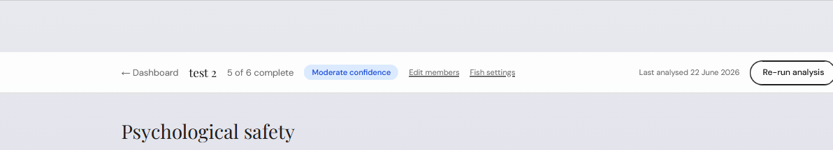
But make that whole banner much bigger.
- SHARED PURPOSE
[I want Otis to analyze member’s statements about share purpose and come up with a 50 word opinion on how aligned they are. Otis can use examples from what people said, but shouldn’t call anyone out. Want that in it’s own window (but we have to decide how oatis is trained to do this…that I’m not sure. Using embeddings again?)
then below, I want there to be an option to display a dropdown ‘Raw Responses’. This will open up in a drop-down if clicked, then you get each member’s raw response (anonymized) ONLY IF they have permited their responses to be shared

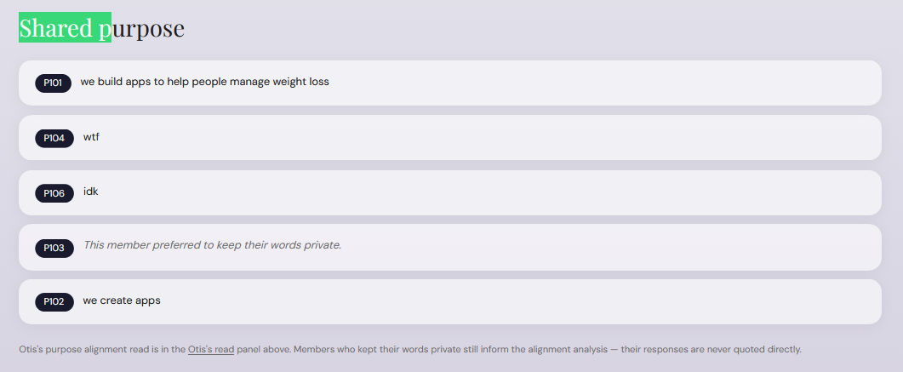
Delete the ‘otis’s purpose alignment read…” which is shown at the bottom of this image.
** note that this won’t factor in to the phase 3, but it will be held in the membory because the team may wish ot address it later**
TEAM CONNECTIVITY
- I think this would be a lot more visually intuitive if we had network analyses that moved closer together when the nodes were more connected, or something like that….i want us to think of network analyses, how they are done, and how this would be easiest to understand visually, either through the line density / color differnces, or the physical distance between the nodes.
I’m also considering this…what if we had 2 netwrok analyses. 1 for geographic distance (if we have it from people’s entries….and if we don’t have someone’s entries then that person who didn’t respond gets a symbolic circle that’s not connected and n the side.) and 2, for the coordination network which is in the current image (showing how closely they work together). Actully, this might be visualized in one network (if it makes sense) where the thickness of the line represents strength of coordination, and the distance of the nodes represents geographic distance. Give me your opinion.
(Give me also suggestion for what the text should report, because right now it’s not in plain English and I’m not sure if it’s even useful information, that with the density? Like why would they want to know about density? What does a more or less dense network say, especially if considerd alongside shared purpose or psych safety? We wont action these insights now, but this might be something to consider)
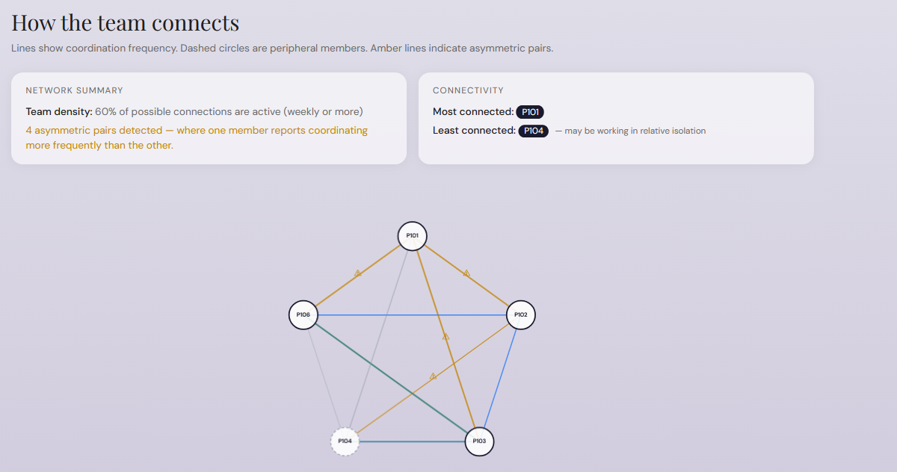
-PSYCHOLOGICAL SAFETY
We can open with the below image:
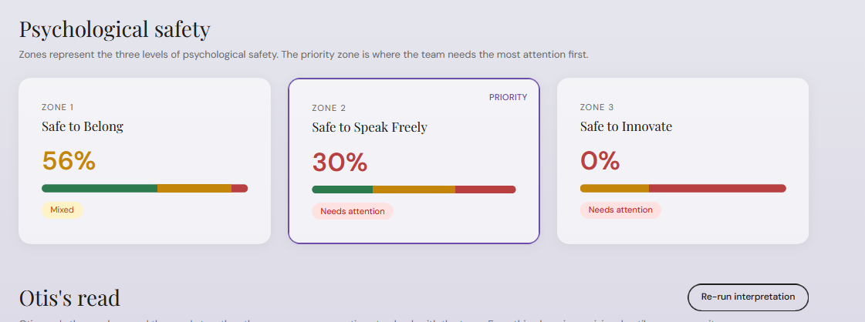
And underneath the 2 zone percentages (which actually ins’t that clear….that does 0% mean in the picture above…. Is there a more standard and clear way to say what percentages are? Or should we evan have percentages? And should we somewhere indicate clearly what red yellow and green mean according to the ‘disagree vs agree’ etc.)
Anyway, below that, in smaller dropdonw we could have ‘Survey Item Breakdown’
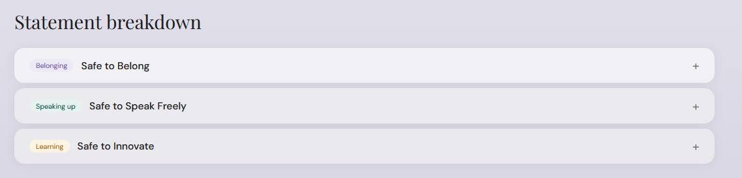
And we’ll have to decide what the expanded verisons look like with all that red-yellow-green buisness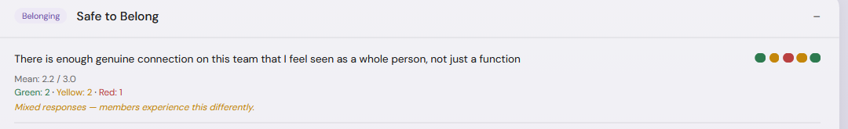
But in the ‘Ot’s read’ section, I want that to be split up into sections that describe each of the zones (again, we need to figure out how to help Otis make the best conclusions possible. Like, I have some materials that I wrote about psych safety and what the different zones might mean. So can we maybe use that to help determine what it would say under different conditions? Or do we need to simulate a lot of data and train it/ check it, like that?).
And actually, I want to incorporate the image somehow….maybe in the background . I’v indicated in white where Otis’s read can fall. And I don’t think it should be longer than 200 words. It should be a conclusion about what it suspects about the team, based on their scores. Because low scored here may indicate that ‘__’.
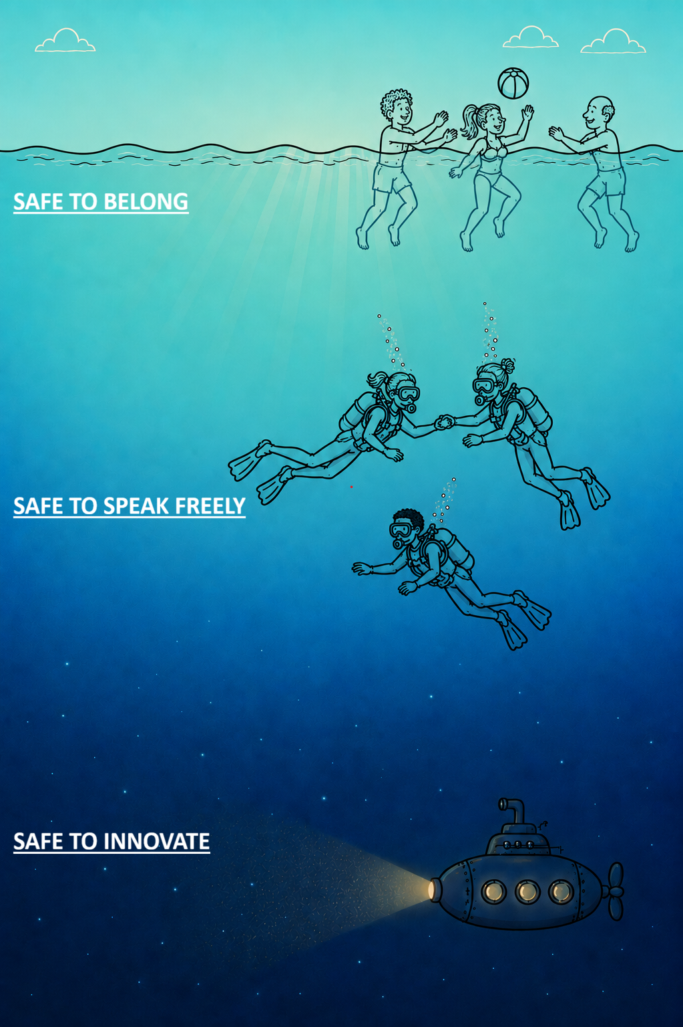
-TEAM STORIES
This is where we get the most info about the answers people gave. Otis did the analysis of the open-ended questions as described above, and now it’s time to choose what to display to the front-end user. I think it makes the most sense to start from the specific psych safety questions that members told stories about. Maybe we have a descripitn like: “Otis asked every member to tell them why they scored their lowest-scoring items through storytelling of past situations. Otis also asked members to imagine what a better outcome would look like.”
then a section
“lowest scoring items” (and here we place the psych safety items that stories were told about at the top, by order of how many people told stories about that one, and order the preference base also on zone that are lower, and make it clear which psych safety zone items belong to). There might be several question items that are displayed here, but just show the top 3 and then make it expandable if the user wants to see all of them
When you click on each item a siplay opens up that shows the breakdown of the situation (context & objective), out behaviors, results, and in-behaviors that OTIS coded in association with that item. This could be put in narrative form, e.g. users discussed ‘update meetings where they asked for help, where the team didn’t offer allow time for problems or support issues to be raised, and the outcome was greater frustration and difficulty when completing tasks, which might have been improved by having time for equal speaking turns during meetings to raise issues.”. If multiple people responded to that item, then they get their own narrative sentence(s).
Underneath this section, lets have the lables for each of our buckets (situation etc) displayed all together, basically we have a box for each bucket and we dislay Otis’ results. I detailed what the analysis would entail, and what the results would look like earlier in this document. See above for example:
(SITUATION BUCKET)
- Context sub-bucket
  - Dashboard should show counts of which contexts were discussed. E.g:
    - Update meeting (2)
    - Email (1)
    - Chat thread (2)
    - DM (1)
- -WORKSHOP SECTION
Okay Now I wonder if it would actually make sense to have this whole dashboard be able to toggle between the ‘ANALYTICS AND INSIGHTS’ AND ‘[ some kind of title for the activity? The workshop? Phase 3…what do we call it]
Basically everything that’s been described so far would be in the analytics. and in the [lets calle it workshop for now but I’m open to ther suggestions] workshop tab, we have the area where we are building the activity that they will do in the next phase. I think that Otis should be available to chat in both tabs….maybe as a bubble down by the right left? It’s the image of the octopus, like ‘clipy’ lol. So Otis can talk about things with the consultant as it’s reading over the pages. And Otis will be there to help build the in/out activity.
In the ‘workshop’ section, this is where Otis makes its preliminary suggestions about what the team should make a ‘Team Agreement’ about. Otis suggests that the next phase focuses on guiding the team through an activity that will increase their ability to [e.g. use moments when things go wrong as learning opportunities, not blaming opportunities; understand and value one another’s contributions; give everyone time and attention to express their perspectives] , especially during [situation (context objective). E.g. during update meetings/retrospectives/slack channel discussions/project work when admitting mistakes/experimenting with new ways of working/reacting to someone’s ideas/finding solutions to a problem/planning future work).
Otis doesn’t have to explain WHY it picked this item, but maybe in a small dropdown off to the side it says like ‘Otis’ reasoning’ and here we have how it made the decision. Or the user can ask in the chat. (make sure we have the selection logic understood, tell me if we didn’t cover that in enough detail or make decision around that enough).
Otis then explains “the activity will involve team members (either individually or in pairs) thinking about the behaviors that they would and would not want the team to display during these situations, if the goal is to ‘use moments when things go wrong as learning opperunities, not blaming opperunties’. This is done by discovering which behaviors are Red (never appreciated; disallowed), Yellow (approached with caution), and Green (highly appreciated; reinforced and rewarded).
“Otis has identified behaviors that team members have mentioned themselves.”
{Here, we need to determine exactly which lables are displayed. We decided before that we would only have the in/out behaviors associated with the items/scinarios we are selecting from. But there may not be enough and then Otis will pull some more. I want the behaviors to be floating above the circles and for the team to be able to drag them in later.

[out behaviour] [out behaviors] [in behavior] [in behavior] (black color for texts)

Then the a description of what red, yellow, green mean underneath these.

During the activity, users will drag the behaviors to the bucets they think they belong, but they can also delete them if they don’t think they are relevant, and there will also a requirement that they submit at least 1 or 2 more behaviors for the red and green buckets (yellow optional) (even if it’s slightly re-phrasing or similar in nature to a behavior that already exists, try to add more details about exactly what you could want to see or not see.
Once users ‘submit’ their answers, I’m thinking it will go into a a joint pool. Otis doesn’t mess with anything, but if there are exact repeats (or maybe super super similar, but slightly different wording, topics) it makes that word/text bigger in size to show that more people said they want/don’t want this behavior.
….then we have to think about how this relates to the behavioral agreement. I think that this big pool of the red/yellow/green behaviors need to be discussed as a team, starting with discussing in pairs to create codes of conducts for the specific situations, which will read “In this team, when we want to _[objective] during [context], we will [in behaviors]. We will avoid [out behavior]”
PHASE 3:
Otis AI will share the results with each member. These are the team-level results (there should already have been an opportunity for the members to download their indidivual results earlier).
The team members will get to see the same information that was generated in the dashboard. But they won’t see as much detail. They will see in order of appearance
* the networks, first the geographic network and then the collaboration frequency network. I feel this is a good way to remind the people of who it is we are thinking about, where they’re located, and how dense the network is (I guess we can have a small description of…’your team is pretty co-located with some indiviuals working remote…or your team has two sub-groups…etc etc’ and the same sort of description for the frequency (Your team is pretty dense vs not too dense….here we have to think about what makes the most sense in how to describe it? ‘members of your team don’t require frequent interaction with everyone else.>>’ or we could do it like ‘on average, people interact with __# of people daily’ help me think thorugh what would make the most sense. Or we could just show them the network with no real explination except like ‘here’s a breakdown of how often others reported incollaborating with everyone else and the different color lines mean ‘daily etc’….now the question is also do we include people’s names here if we have persmisison to make their data non-anonymous? For transparency I feel like we could….would there be any problem with this? What do you think.
*THE ai summary for shared purpose
*the big-picture statistics and images associated with the zone breakdown (like red, yellow, green…and if we have the percentage …basically we should reflect what’s in the dashboard regarding this and, just like in the dashboard, we should explain what any numbers mean
*The zone summaries (should basically appear alongside or underneath the statistics for each zone. If we could have this overlaying the psych safety ocean again, just like I described for the dashboard, this would be ideal and visually good.
*the team stories for the top 3 (or rather most poorly rated 3) psych safety items. As we transition form the zone summaries to the team stories, I want the zone summaries and statistics to disappear, but the title of the zones (save to belong etc) should stay where they are and the background should also stay the same (the ocean image). And then the question items appear. They should appear in the zone they belong to, and at this point we only show the item (not the associated team stories) and somewhere Otis AI is telling them what they are seeing. So basically we stay close to the script used in the dashboard, e.g. ‘Otis asked every member of your team why they scored their lowest-scoring items the way they did, by telling a story about past situations. Otis also asked members to imagine what a better outcome would look like.’
It might be that we have 3 items all from the same zone, and we wont be able to display the team stories all at once. So we could display the items first, without the discripion or stories underneath (along with the intro), and then the user has to click through to the next page to read them one at a time. They sort of open up and expand to show the stories. (Claude…do we have to write a guide for Otis about how to create team stories or did we already do that?)
*pulse check ( claude, how do you recommend we handle this…what’s the pulse check asking? About team stories or about the ?’ about all of the results so far?’ Maybe it’s better to do a pulse check about the AI summaries and assumptions it’s making about the zones or shared purpose instead of about the stories. Because stories come form members….that’s not necessarily something we want to question. …im open to suggestions here’
- *Then the introduction to the workshop. “We’ve come a long way in understanding what psych safety looks like in your team and where there’s room for improvement. I mentioned before that when it comes to psychological safety, it’s impossible to reach deeper levels of the ‘ocean’ before we feel safe close to the surface. The next step towards developing your team’s psychological safety is to focus on making it a safer place to [safety zone, belong/speak freely/innovate], by making sure that [safety item, e.g. disagreeing or seeing things differently is welcomed, not just tolerated; the team gives everyone time and attention to express their perspectives}. Since members of your team discussed this topic with me in the context of [objective and context (must make sure the sentence reads logically ), this is where we will focus.
- ‘What’s great is your team has already flagged behaviours that might be working against psychological safety, and made suggestions for behaviors that might be better. Please take a look at the following activity, as a preview for what you’ll do during the workshop “ (Then display the following, which will be the activity that the user interacts with to drag and drop the behaviors into the right categories)
(TITLE ABOVE THE BEHAVIORS AND CIRCLES:” In order to make your team a place where [safety item, e.g. disagreeing or seeing things differently is welcomed, not just tolerated; the team gives everyone time and attention to express their perspectives}. What behaiors do you never ‘never want to see’ ‘maybe want to see’ and ‘always want to see’ when (objective & context).

NEVER MAYBE ALWAYS

- “1. Please drag and drop the behaviors the circles you think they belong
- “2. AND_ add at least one behavior in your own words to the “never” and “always category.” “

Your workshop facilitator will guide you to discuss your selection, first in pairs and then with the whole team to work towards agreeing to 2 behaviors your team will ALWAYS demonstrate, and 2 behaviors your team will NEVER demonstrate in this situation. Your team will discuss any barriers that might stand in the way of committing to this goal to this ‘Team Behavior Agreement” for 30 days.”
“That’s all for now! I’m looking forward to continuing this work with you during the workshop. Ai want to thank you for being apart of this process to make your team a safer, better place!”
(Download the report option)
(finish button this will let Otis ai know that everyone has read the report, which is important prior to the meeting being scedules. We’ll have to think about how maybe the consultant or team leader or whatever is going to schedule this….might have an optional integration with google calander if the team uses this? Or option to send out ‘doodle pole for the next few weeks….some option to help coordinate the meeting that is a low-weight built that’s likely to integrate across different work setups….or just have a place that the consultant/leader in the dashboard can enter the workshop date.)
(the reason I was thinking otis should know when the workshop is, is so that it could email the participants 2 days before (and then 1 day before) if they haven’t yet read the report. The email should also tell them that they NEED to have access to PC or Phone in order to complete the activity. Also does this email include a link to where the user will need to login during the workshop in order to complete the activity?).
(and so the only thing that changes in the dashboard after they ‘finish’ reading the report is that it logs who has ‘finished’, and we get the responses to the pulse survey)
(HERE’S one thing about the whole script for phase 3, I think it should be possible for the consultant to edit any part of this script in the dashboard. Or for Otis AI to only change the script if the team is already golden on psych safety. For the beta though, I say don’t change the script, but do let consultants edit it. Because the working should probably change, and even the activity and focus, if the team doesn’t have any maor problems. )
PHASE 4 DURING THE WORKSHOP
(now, claude, you’ll have to help me think about exactly how this is going to work…. Basically in the dashboard I guess the consultant needs to go in and sort of ‘start’ the workshop? Or something?.
lets picture that everyone is on a zoom. And they are each logged into their individual Otis ai account…?? Is it an account? Or do they always have a new link (like could they see their previous reports and responses, and then also there’s a place where they see the ‘workshop’, they could like ‘enter the workshop…because the workshop is live right then’.
…need to think thourhg this.
because essentially they need to fill in the activity individually, and then once they hit ‘submit’ that will send their responses to the team’s pooled ‘never’, ‘maybe’ ‘always’ responses. Now the user can go to view the pooled responses…there still might be responses coming in but once everyone’s done then the facilitator will break the team into breakout groups and instruct them to toggle the responses for you and your partner “so sam and sally, you’re in a team, so just click on your names and view how you both sorted the behaviors. See there’s any place you agreed or disagreed, try to explain your reasoning to each other. Then pick your top 2 ‘never’ and ‘always ‘ behaviors….try to come to an agreement about which ones are most important. Try to think about what it would actually mean to commit to these behaviors. What barriers would there be? How can your team make sure we do (or don’t) show these behaviors? ” So even on the website the users are logged into it would be great if we somehow had the instructions or had these prompt questions displayed so that pairs knew what they are supposed to answer. And even had a place to type comments or responses to the answers. But I don’t know if Otis can be intelligent enough o know when they are in the ‘individual’ phase, the ‘pairs’ phase, or the whole team phase…
Because during the pairs phase, I want them (both of the people in each pair, or there might be a group of 3 at some points), I want them to essentially submit a ‘vote’ on which behaviors they think make the most sense and they can even write their own together and vote for that one as the ‘never’ or always’ behavirs. and now here’s where Otis has to do some live computing because once everyone is back from the breakout room the facilitator has to kind of trigger the ‘team’ phase, where we get to see the votes. And then we ask each pair to explain why they chose those. Now here’s where the facilitator will guide some open discusson because they may need to resolve a tie between behaviors for example, and they may need to address barriers or facilitators to the behaviors. I feel like during this portion, I feel like the facilitator should have access to Otis AI…I don’t think the other users should..and then we’ll tell Otis AI that the team has chosen [ the behaviors], the team has discussed [these barriers and facilitators, or other conditions that should be commited to in order to to help behaiors surface (or not surface) and we read this as a team.’ And it’s possible that we need to hash some things out before the workshop is over but if it all goes according to plan we’re most of the way there to a team agreement and we can maybe edit the AI’s words a bit but then ‘approve and finish’ the workshop.
after the consultant or facilitator might nee dto hash some other details out (especially if not everyone was involved in the meeting they will try to get their imput…if for instanc ewe have to have 2 workshops at 2 different times to cover all team memers, maybe we have to merge the agrements’. So later, in the dashboard, all this information should be logged and we can also send out a ‘team agreement contract’ where we ask people to commit to observing this agreement during the situation discussed, and following up in 30 days to see how things are going and if changes are felt by the team (will have to desing this later).
So
---
below are some sections we can delete I think
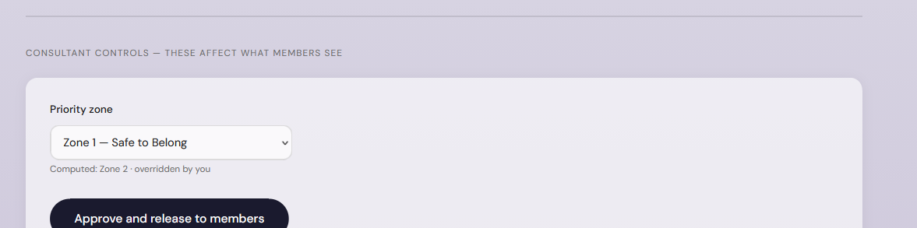
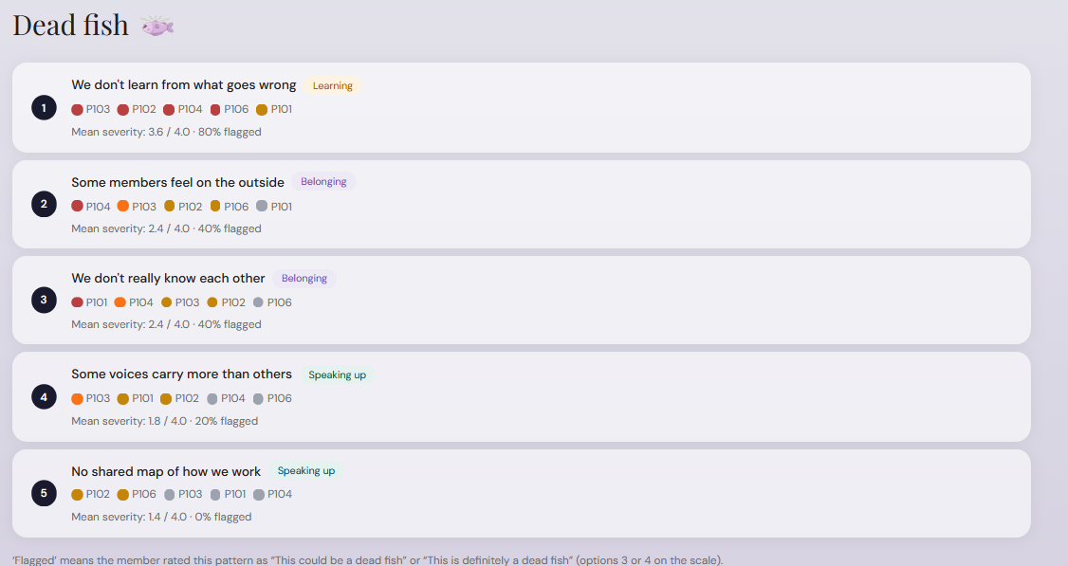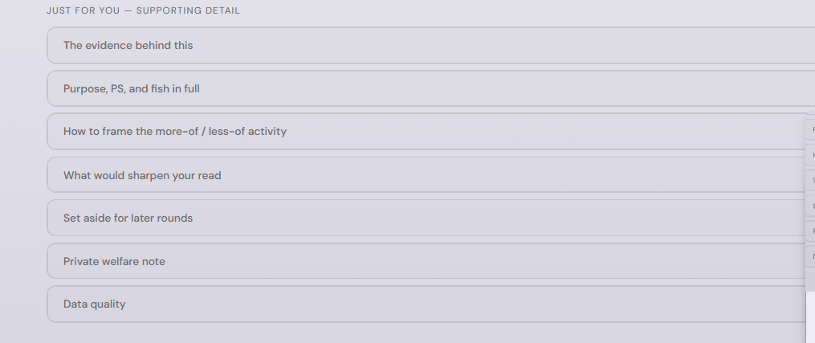
PHASE 4: THE SECOND ANALYSIS.

What were the results and outcomes that members mentioned
  - Otis
- What were the ‘better’ behaviors mentioned (IN)
For each of these, Otis will pull out

Then Otis will compare the

